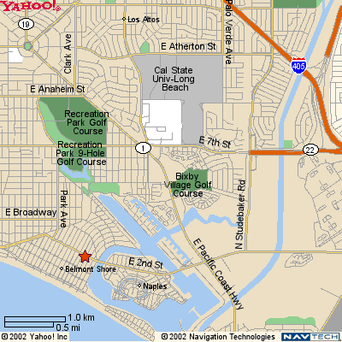

Take 405/605 to the 22 West Exit.
Immediately exit on Studebaker
Turn Left on Studebaker
Studebaker dead ends on 2nd St /Westminster, turn right towards ocean.
Westminster turns into 2nd street as it crosses PCH.
You will go over two bridges.
Cross Pomona, turn left on Glendora.
Park in lot on left.

Office is on the corner of Pomona and 2nd St., above Mailboxes etc.
Enter building from Pomona, up stairs, right to end of hall.

5320 E. 2nd St. #1
Long Beach, CA 90803 562 439 6584
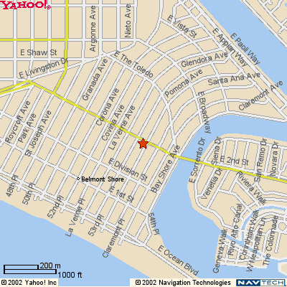

Alternate route:

710 South, exit Broadway.
Take Broadway to Glendora (several miles)
Turn right on Glendora.
Cross 2nd Street.
Park in lot on left.

Office is on the corner of Pomona and 2nd St., above Mailboxes etc.
Enter building from Pomona, up stairs, right to end of hall.

